Send Email from SQL server

https://www.youtube.com/watch?v=AsIho0Qkoro

Step1: Go to Sql server configure database email

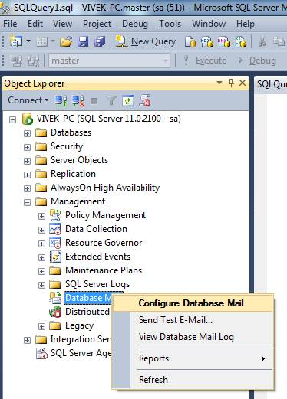

After selecting “Configure Database Mail”, we will get the screenshot as shown below:

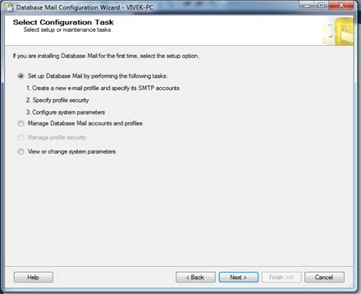

**Step 5**. Select the Radio button on the first option “Set up Database Mail by performing the following tasks” and click the Next button.

We will get a new Screen for setting up the account details for configuring the mail.

**Step 6**. Enter "Profile name" and "Description", as shown below:  
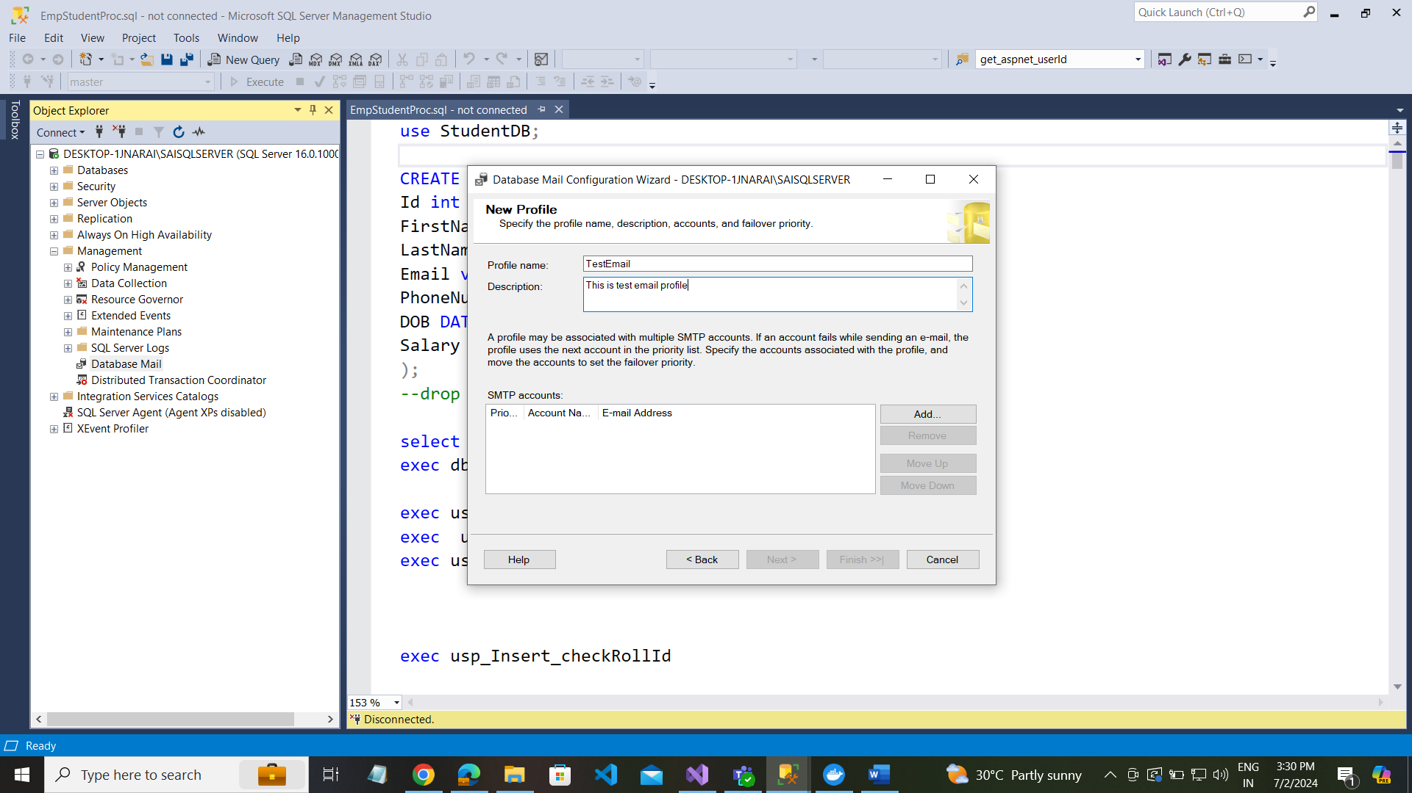

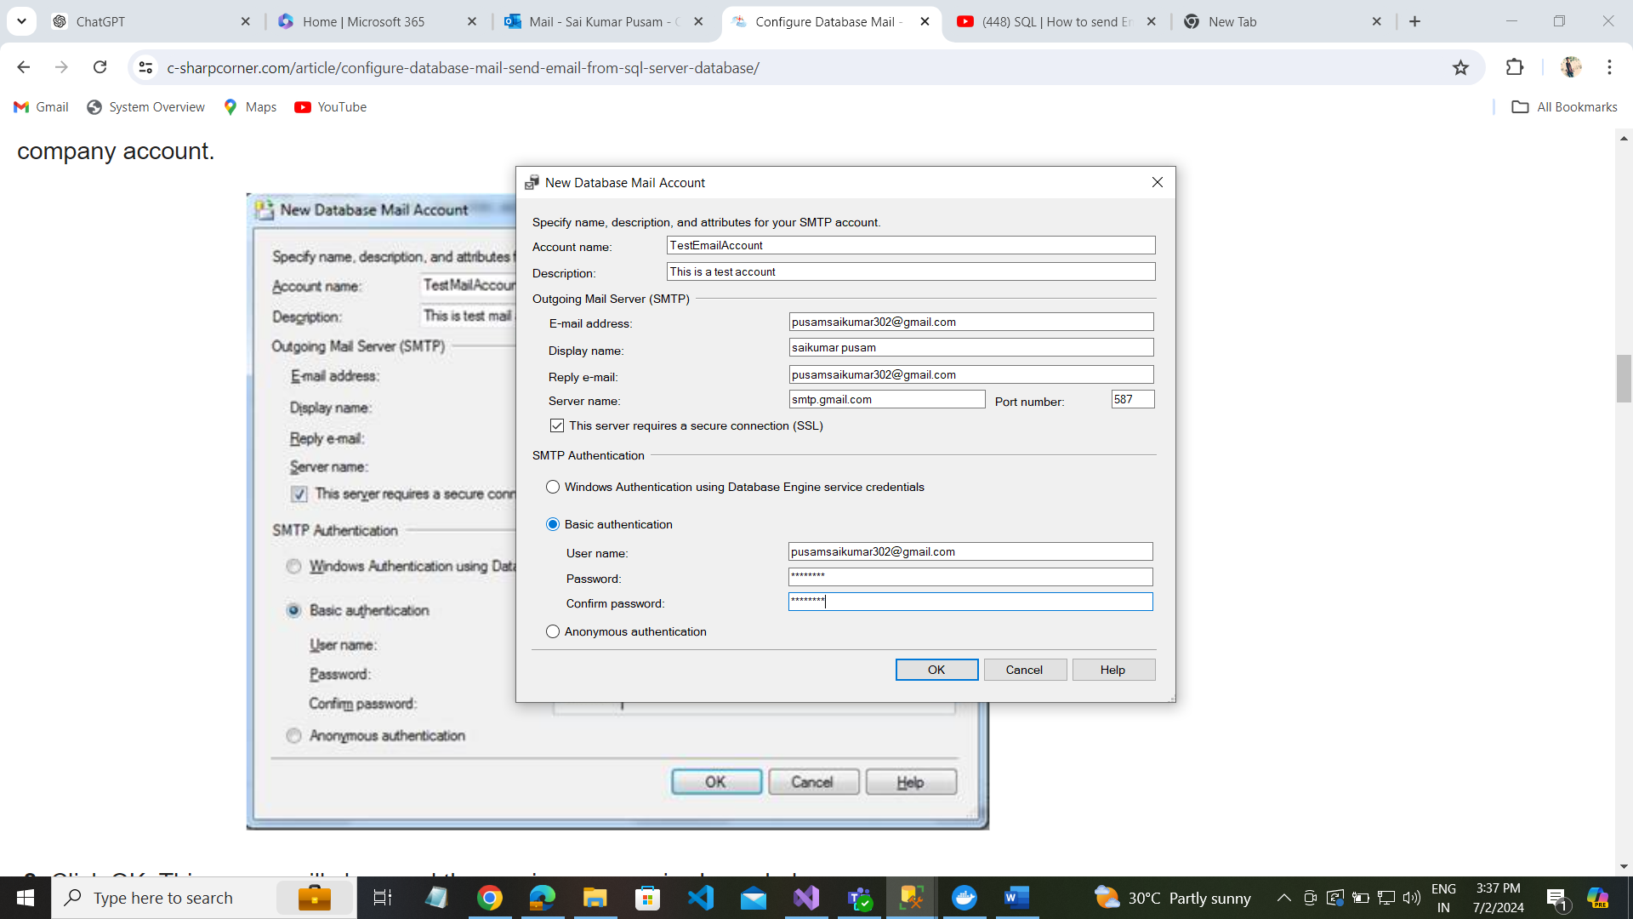

**Step 8**. Click OK. This screen will close and the previous screen is shown below.

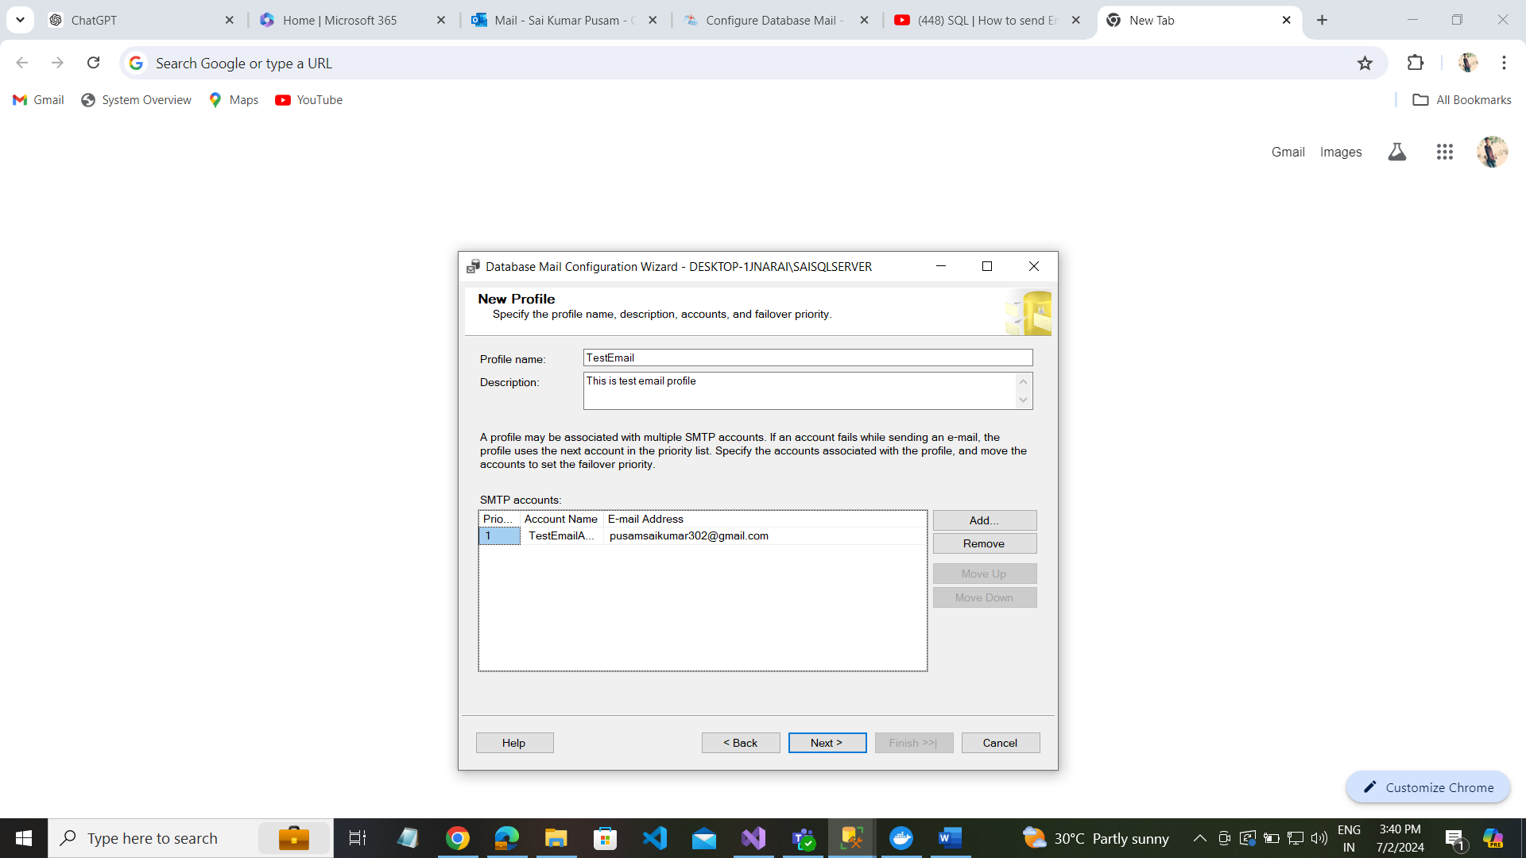

**Step 9**. Click Next and we will get the prompt.

**Step 10**. Check the checkbox on “TestMailProfile” and make it the default profile, as shown below.

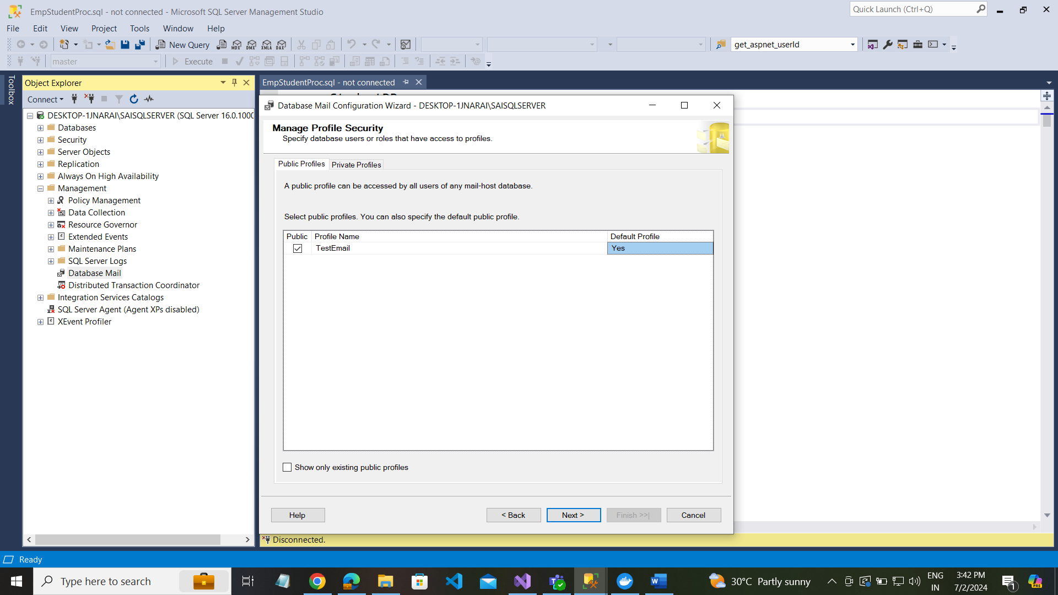

**Step 11.**Click Next and we will get a new screen.

**Step 12.**Keep the default setting for the system parameters and click the Next button, as shown below:

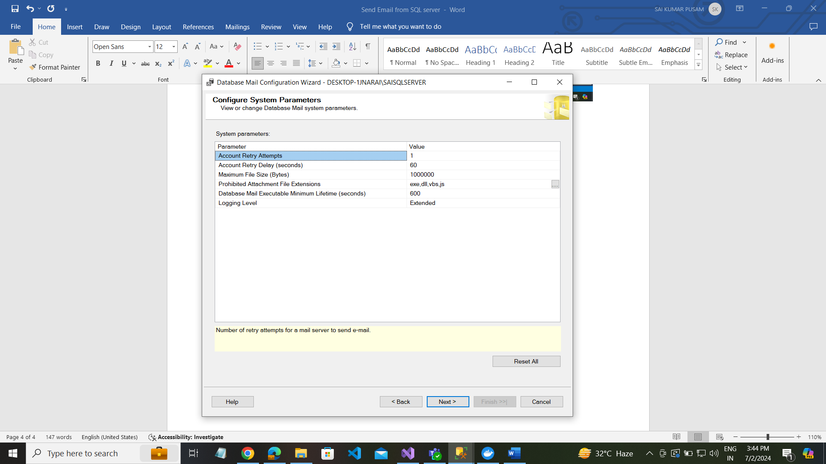

**Step 13.**Click the Finish button to complete the configuration, as shown below.

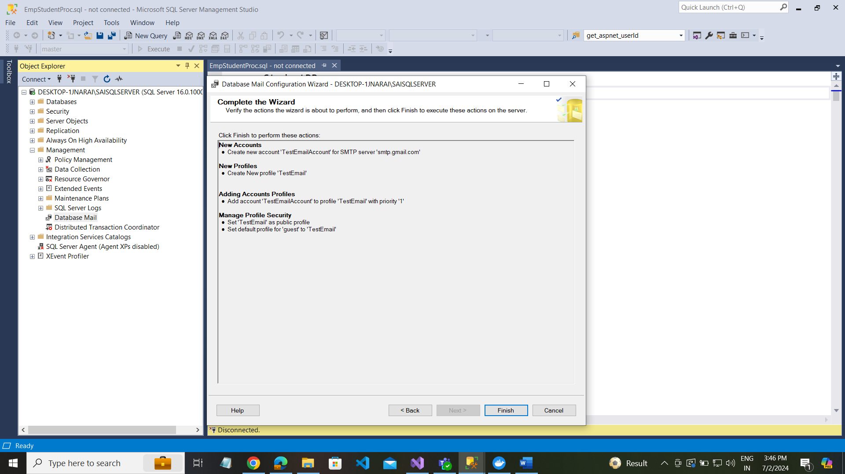

**Step 14.**It will do all the configurations and then click the close button.

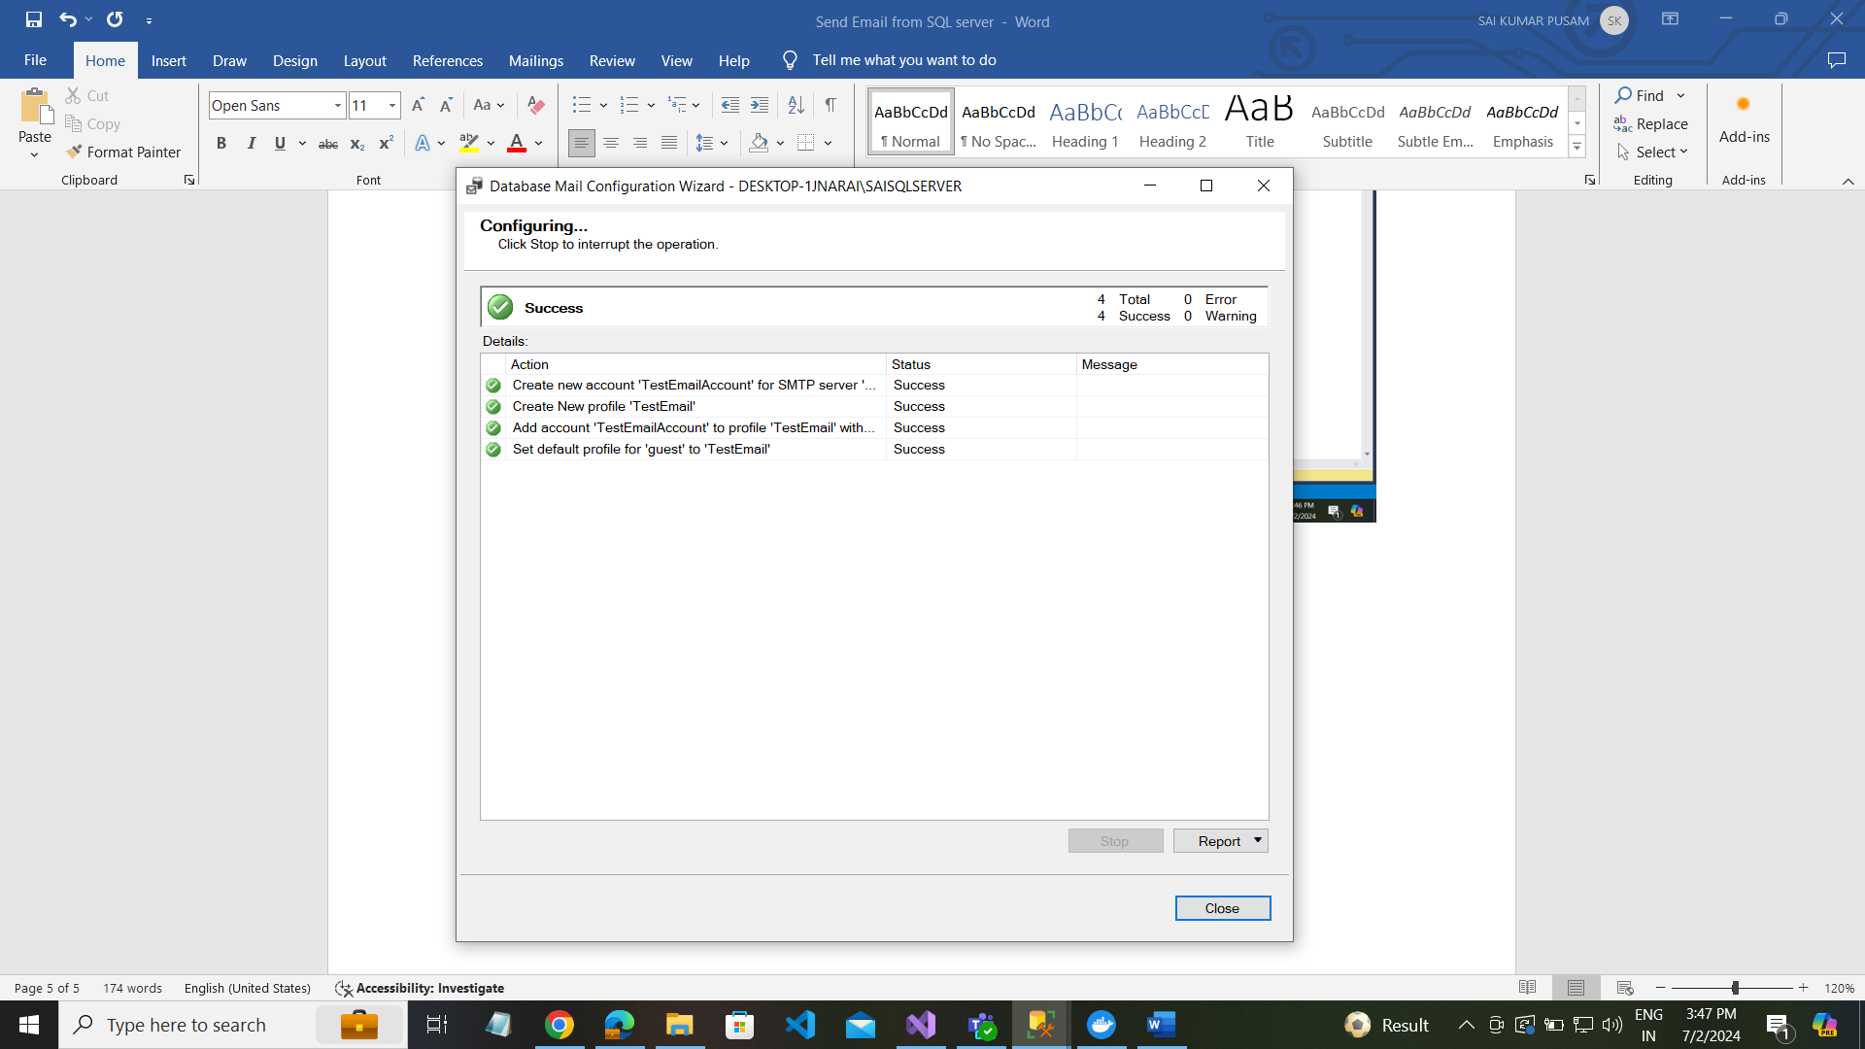

Now, we are done with the mail configuration. We will test this to send a sample mail, with the help of the following steps.

**Step 1.**Go to Object Explore

**Step 2.**Expand the “Management” menu

**Step 3.**Right Click “Database Mail”

**Step 4.**Click “send Test E-Mail”, as shown below.

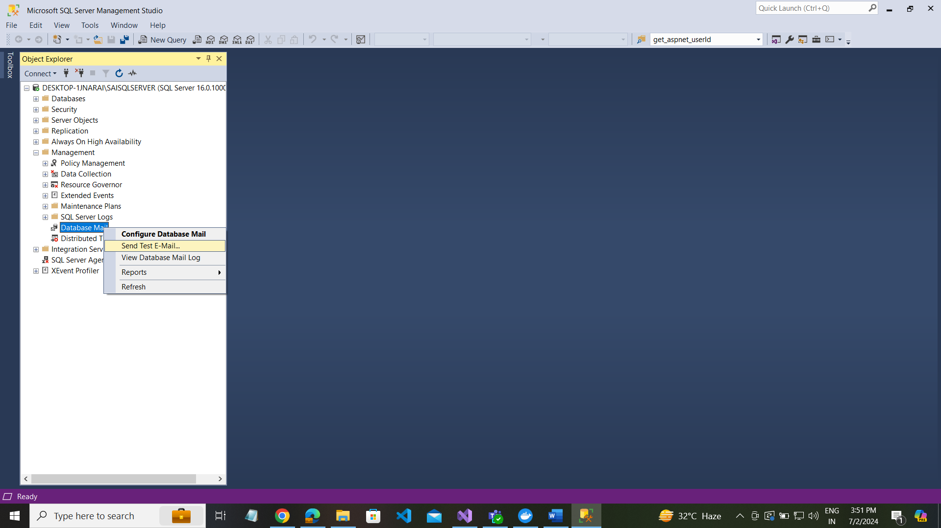

After clicking “send Test E-Mail”, we will get a new screen.

**Step 5.**Database Mail Profile: Select “TestMailProfile”, as we created just now.

* *To* Enter an e-mail Id of the receiver
* *Subject* Enter the subject of your e-mail.
* *Body* Enter the content of your mail.

Click the “Send Test E-mail” button, as shown below.

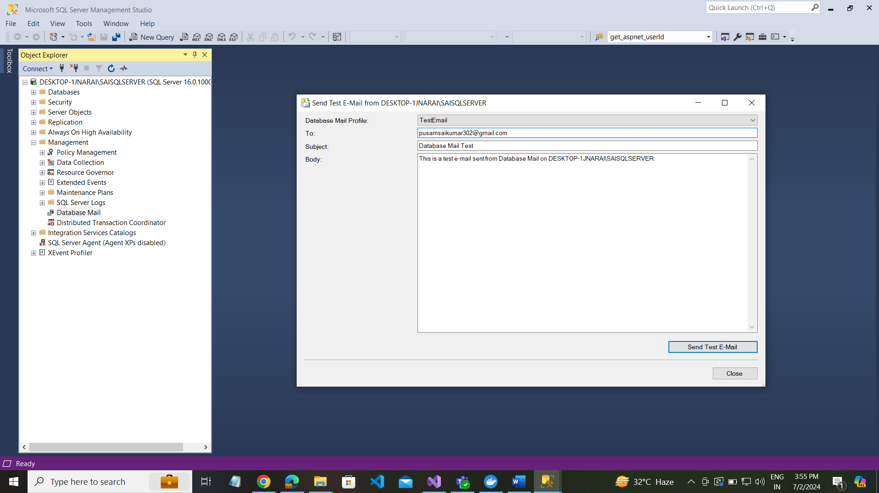

To view all list of email using following below query

use msdb

go

select * from sysmail_allitems

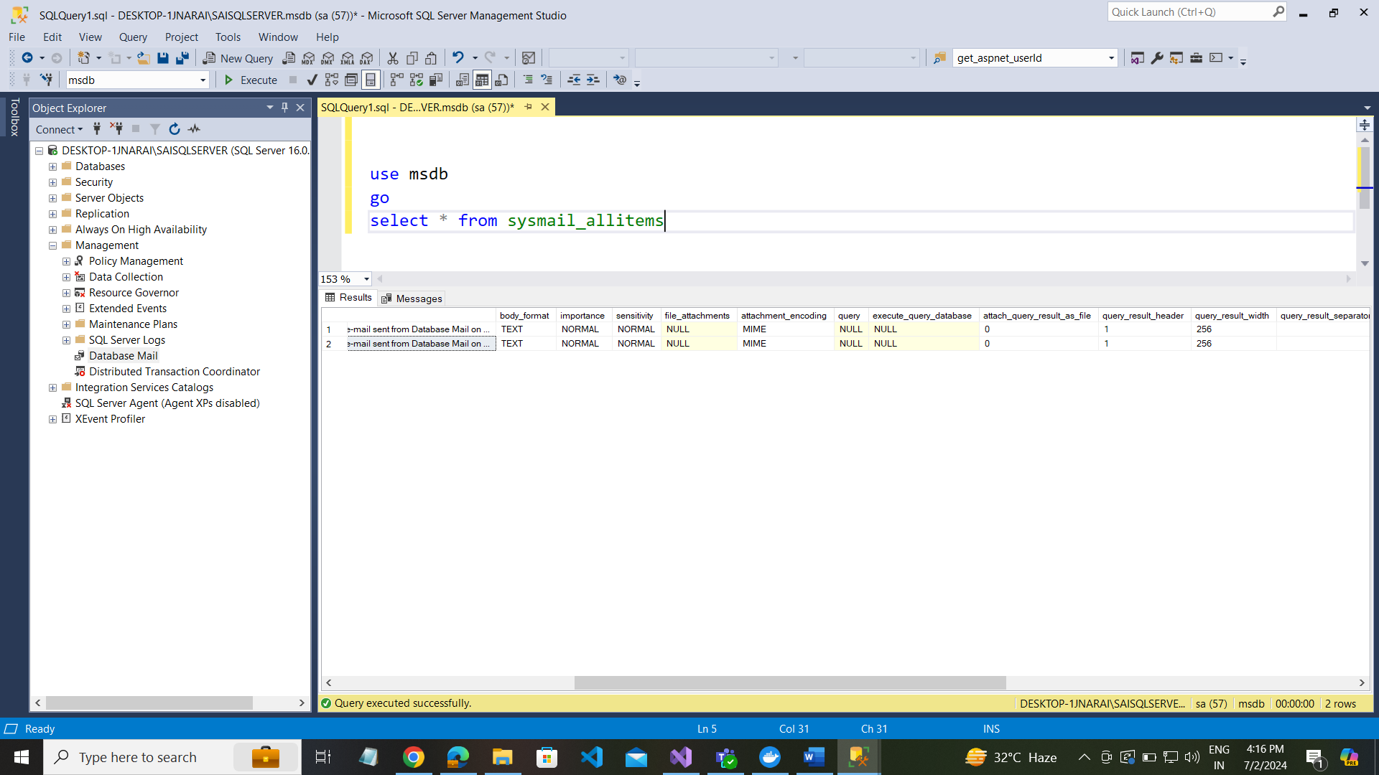

Send email from sqlserver with store-procedure:

use msdb  
go

EXEC msdb.dbo.sp_send_dbmail

@profile_name='TestEmail',

@recipients = 'pusamsaikumar302@gmail.com',

@subject='sql data base email',

@body='this is send from sql server '

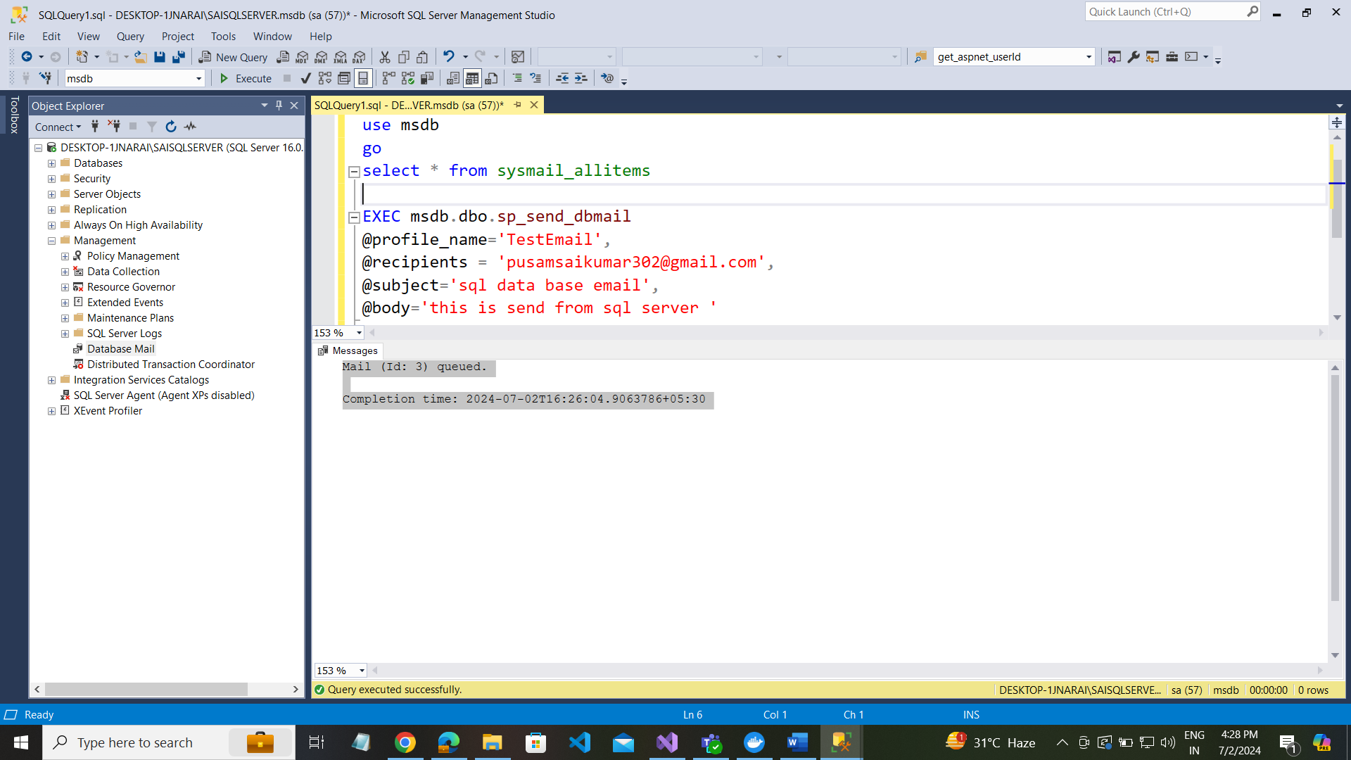

Using msdb to send email messages

Go to msdb as below :

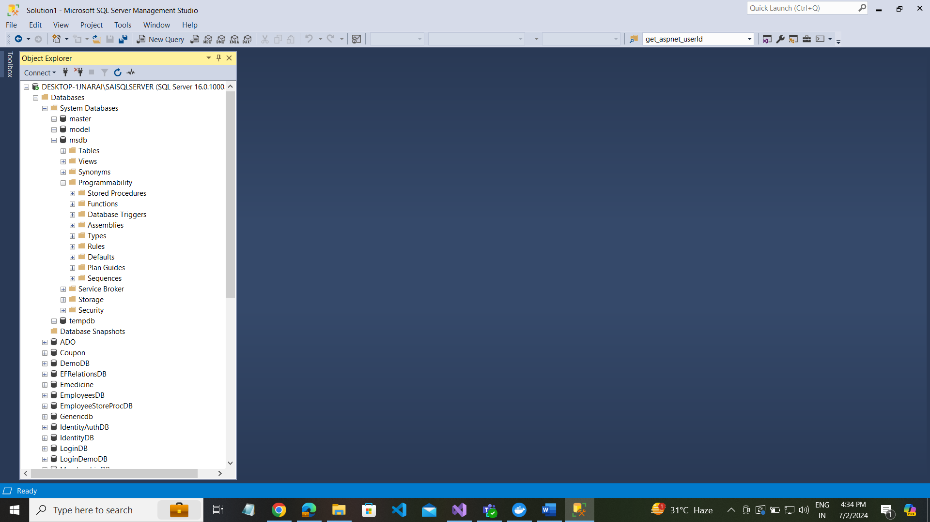

USE msdb;

GO

--- Creating a database profile

EXECUTE msdb.dbo.sysmail_add_profile_sp

@profile_name='TestEmailProfile',

@description = 'Send Email Notification from sql server'

----

Configure the App Password from Gmail security

--- go to your email account

--- go to security

--- search app

--- login with your email password

--- Create APP ex: SQL-Demo

* Its generated password

kvgk wsrl jbvd oqjl

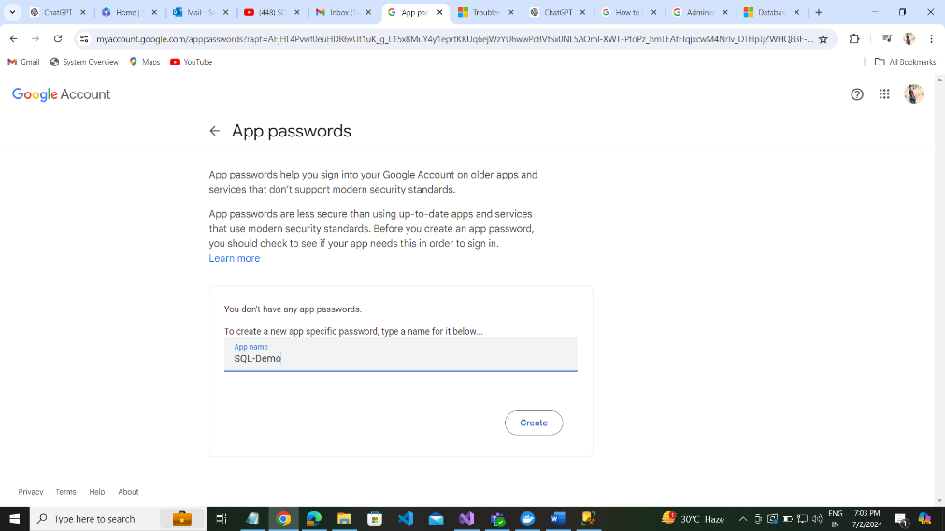

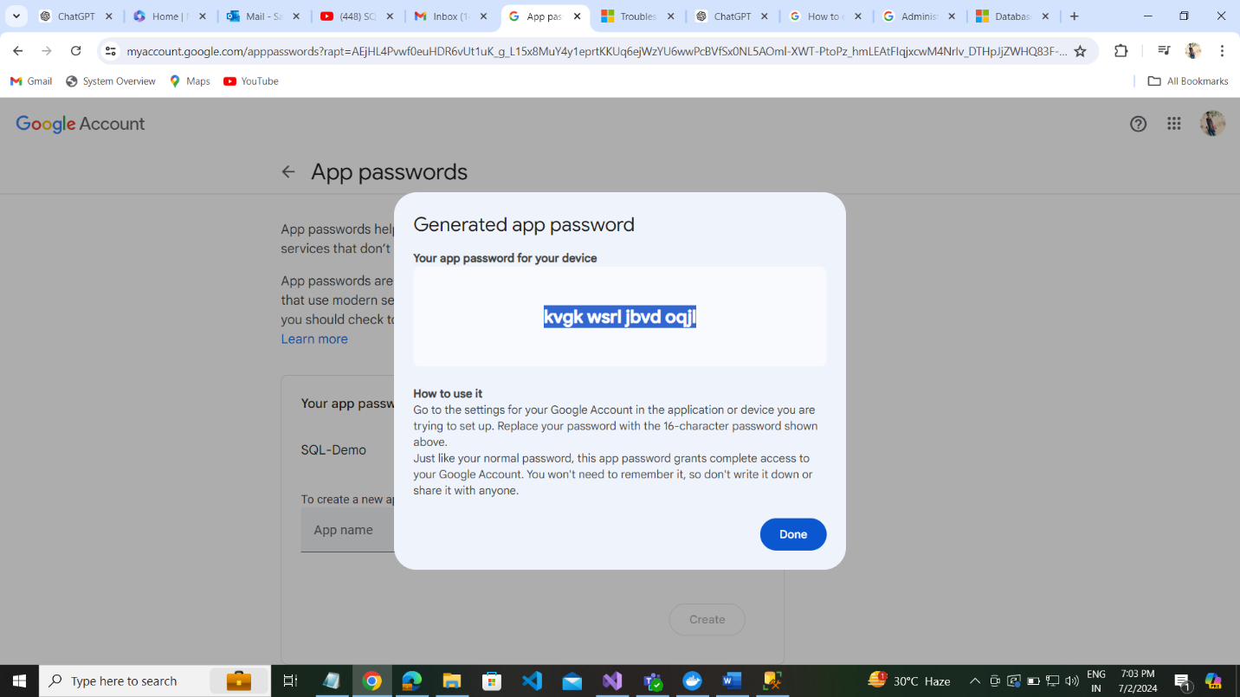

---- creating a email account

EXECUTE msdb.dbo.sysmail_add_account_sp

@account_name='SaiTestAccount01',

@email_address='pusamsaikumar302@gmail.com',

@mailserver_name ='smtp.gmail.com',

--@port=25, @port=587

@port=587,

@enable_ssl=1,

@username='pusamsaikumar302@gmail.com',

@password='kvgk wsrl jbvd oqjl' ----- this is the app password from google security --- for access email from sql server

---- Add email account to your profile

EXECUTE msdb.dbo.sysmail_add_profileaccount_sp

@profile_name='TestEmailProfile',

@account_name='SQL Email Account',

@sequence_number=1

---- Granting access to the profile to User/role

EXECUTE msdb.dbo.sysmail_add_principalprofile_sp

@profile_name='TestEmailProfile',

@principal_id=0,

@is_default=1

---- Enable database email

USE master

GO

sp_configure 'show advanced options',1

RECONFIGURE

GO

sp_configure 'Database Mail XPs',1

RECONFIGURE

Send email without password from sql

https://mailtrap.io/blog/sending-emails-from-sql-server/

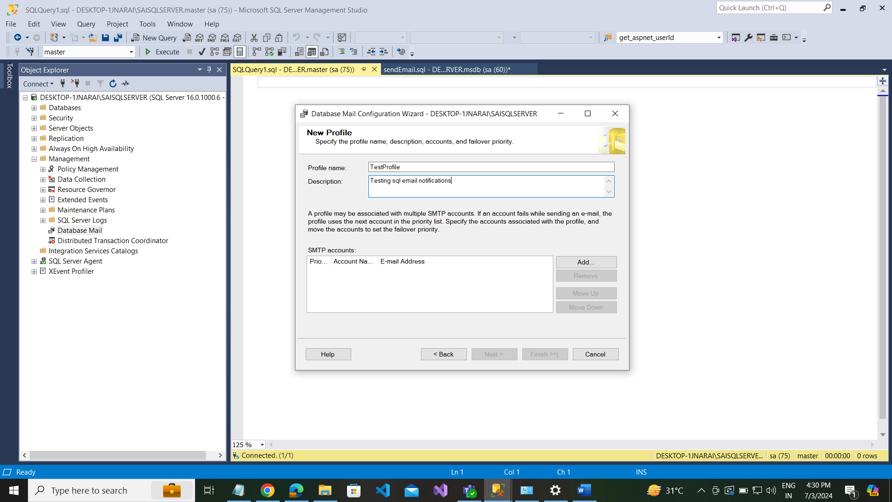

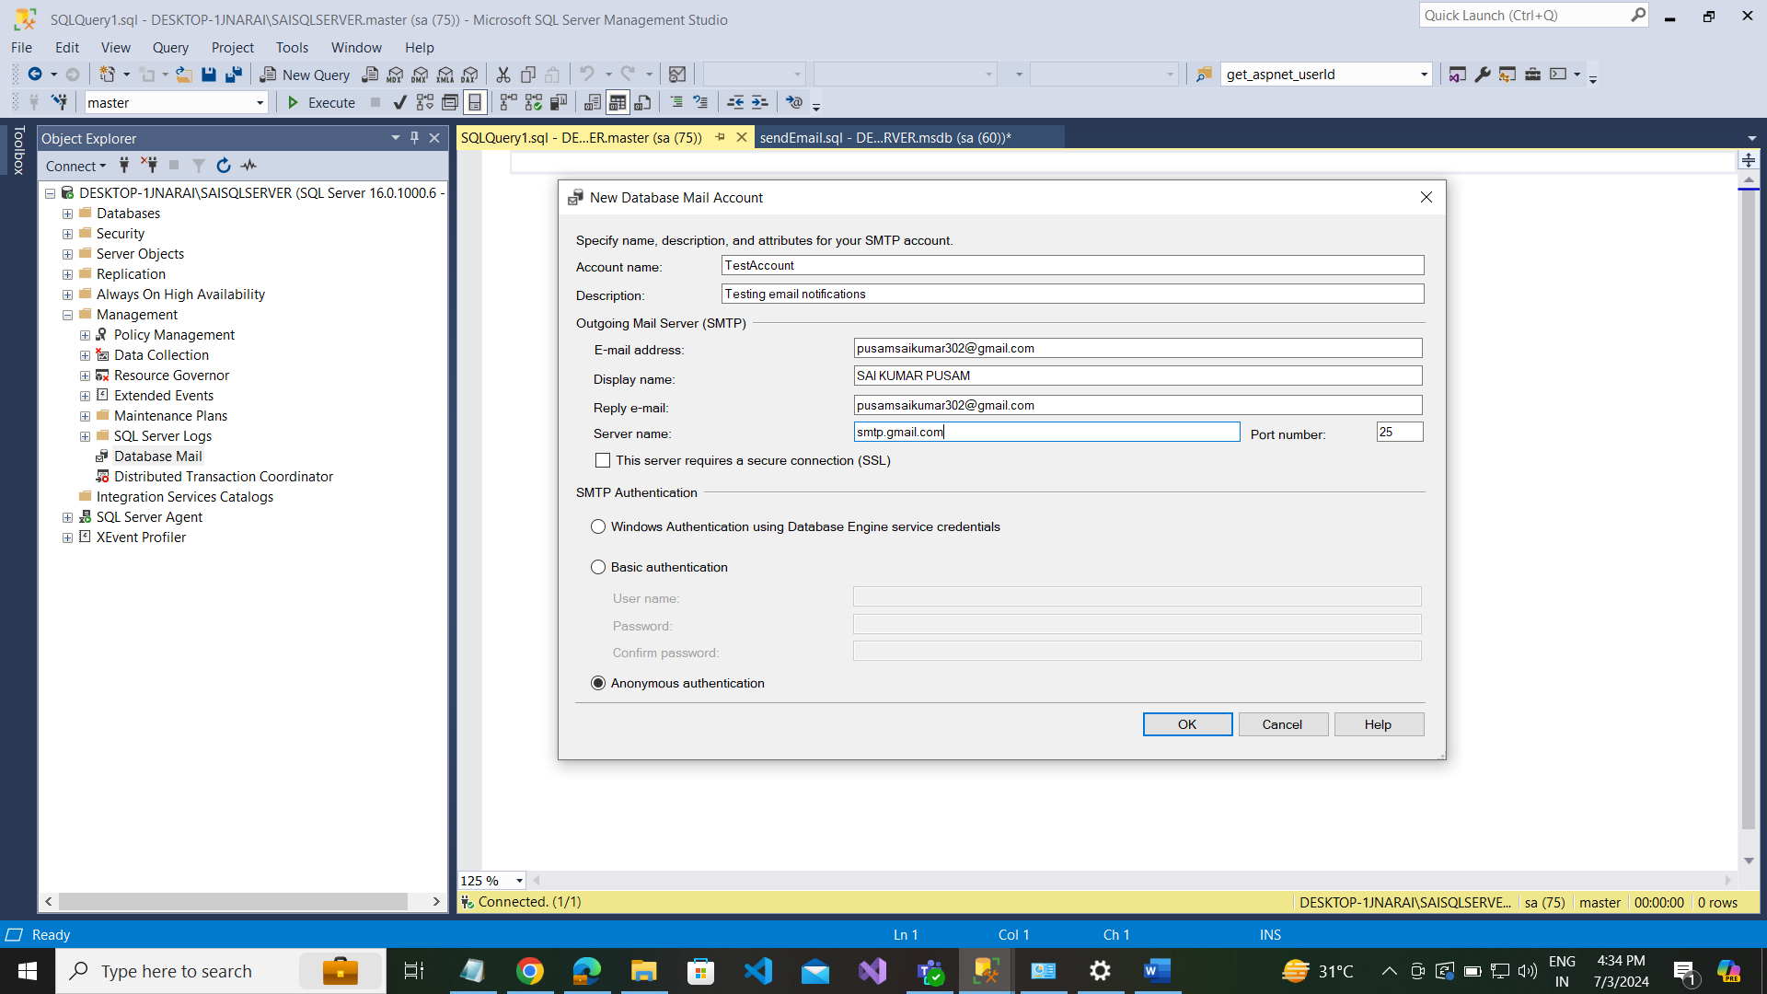

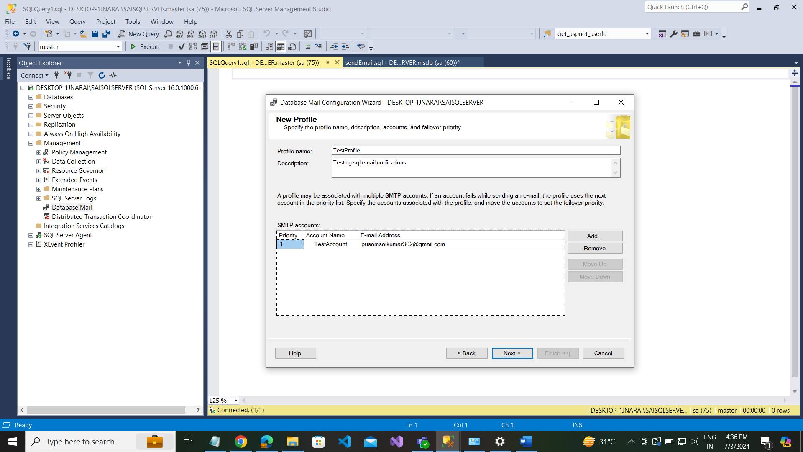

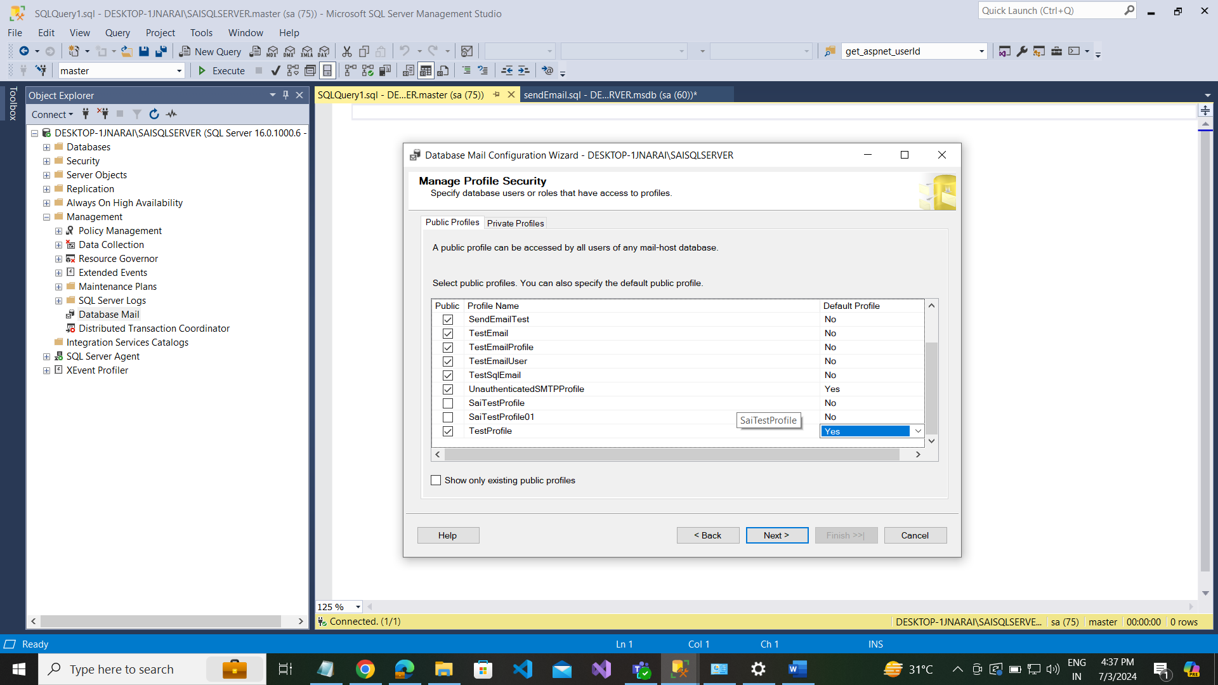

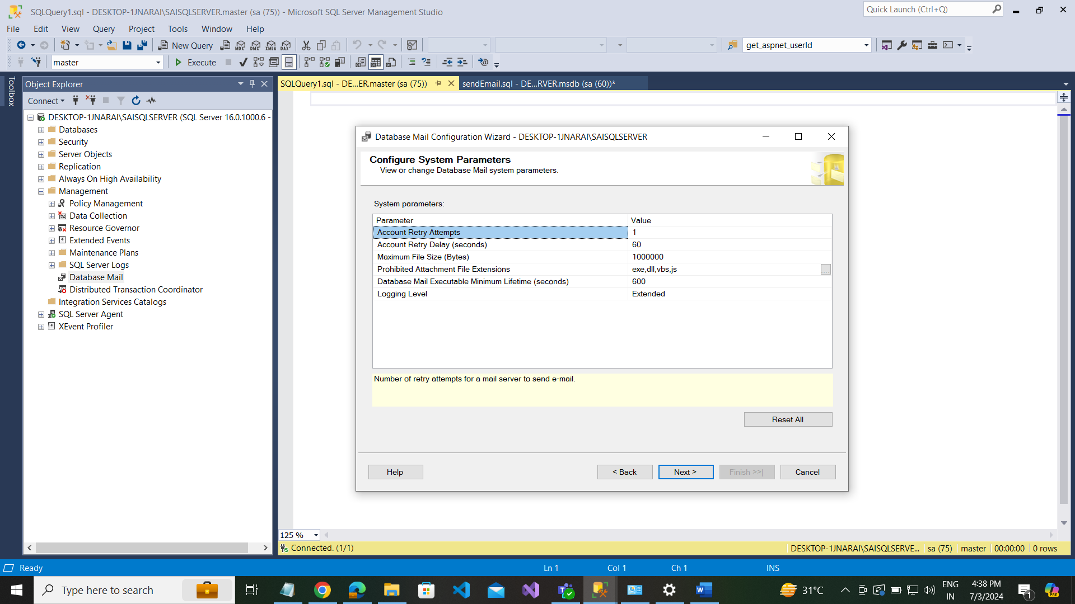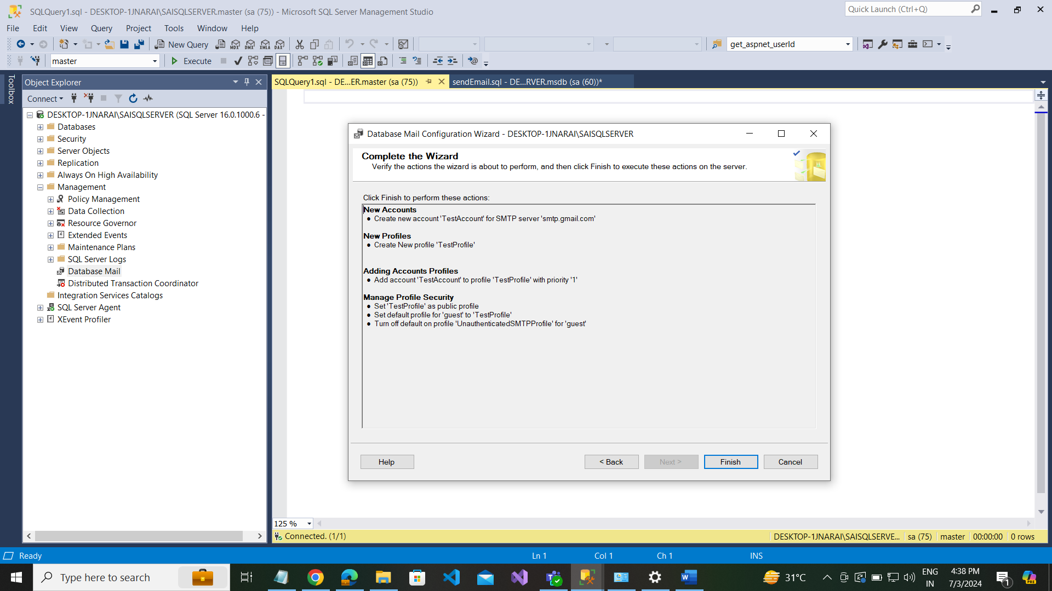

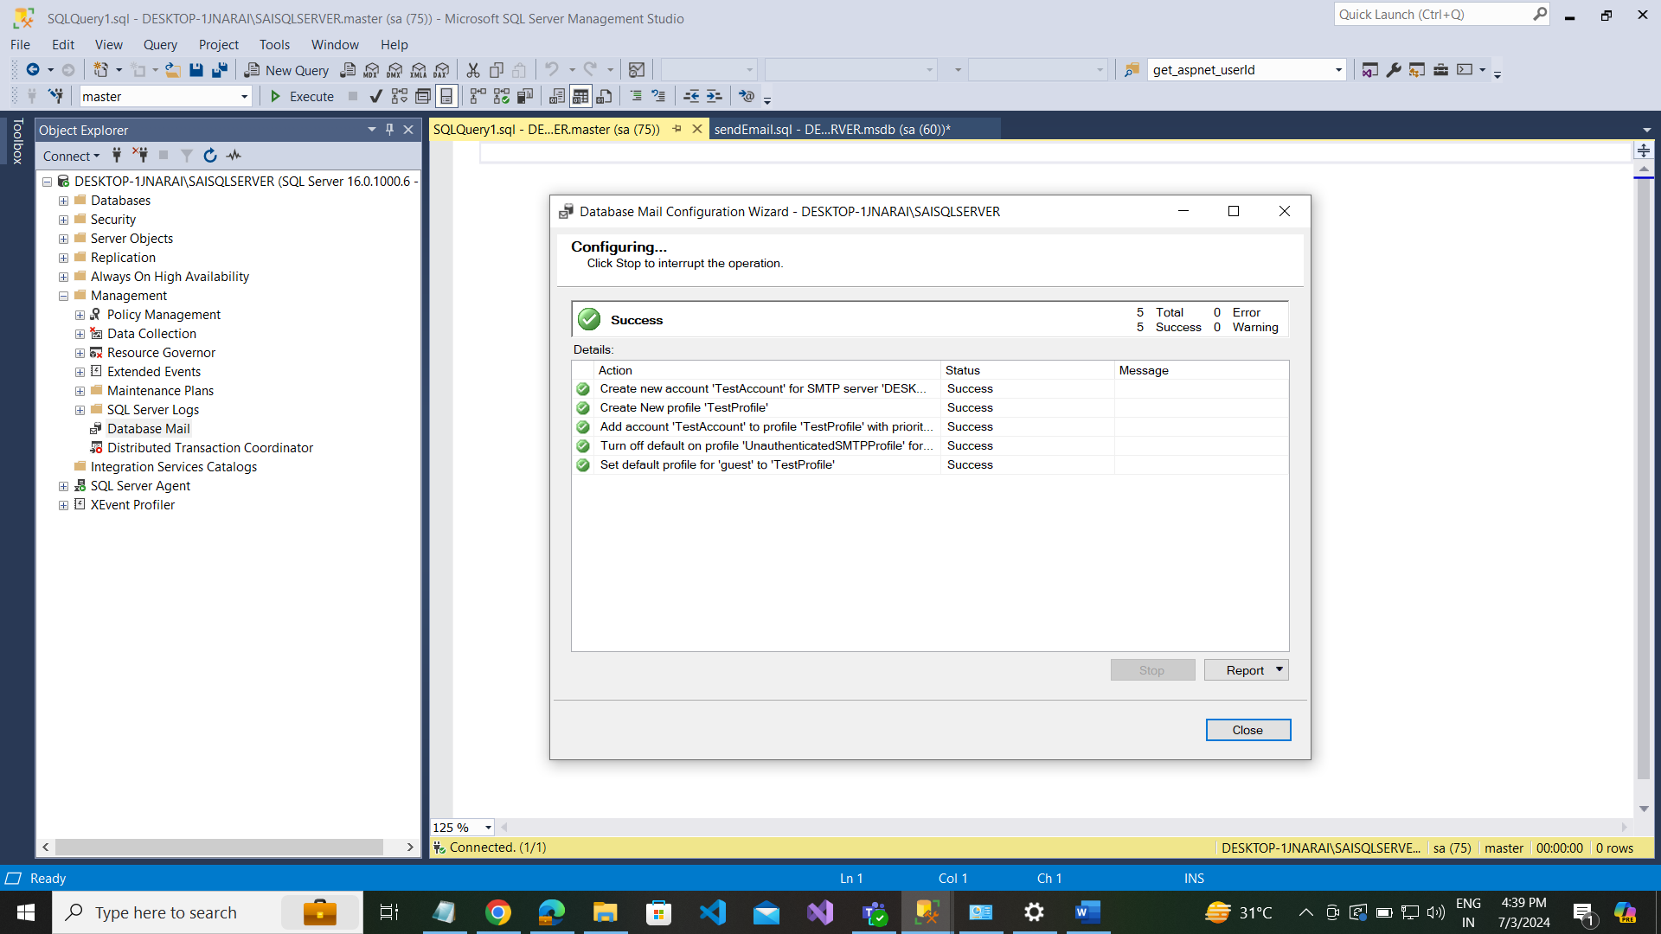

Using office 365 :

USE msdb;

GO

select * from sysmail_allitems

----- OFFICE 365 START ---

--- Creating a database profile

-- APP PASSWORD: bfrplbkqxdckbvdt

EXECUTE msdb.dbo.sysmail_add_profile_sp

@profile_name='OutlookProfile01',

@description = 'Testing Email Notifications'

---- creating a email account

EXECUTE msdb.dbo.sysmail_add_account_sp

@account_name='OutlookAccount01',

@email_address='saikumar@rsaamerica.com',

@mailserver_name ='smtp.office365.com',

@port=587,

@enable_ssl=1,

@username='saikumar@rsaamerica.com',

@password='bfrplbkqxdckbvdt'

---- Add email account to your profile

EXECUTE msdb.dbo.sysmail_add_profileaccount_sp

@profile_name='OutlookProfile01',

@account_name='OutlookAccount01',

@sequence_number=1

---- Granting access to the profile to User/role

EXECUTE msdb.dbo.sysmail_add_principalprofile_sp

@profile_name='OutlookProfile01',

@principal_id=0,

@is_default=1

---- Enable database email

USE master

GO

sp_configure 'show advanced options',1

RECONFIGURE

GO

sp_configure 'Database Mail XPs',1

RECONFIGURE

GO

---- send email

Use msdb;

EXEC msdb.dbo.sp_send_dbmail

@profile_name='OutlookProfile01',

@recipients = 'saikumar@rsaamerica.com',

@body='Testing messages from Sql database ',

@subject='Sql Testing Notification'